**Chapter 14 Reproduction in humans**

**Multiple-choice questions** (p.14**-41**)

1. D

2. C

3. C

4. A

5. D

Since identical twins are genetically identical, they must have the same eye colour.

6. C

Blood vessel 1 is the umbilical artery while blood vessel 2 is the umbilical vein. The umbilical artery carries deoxygenated blood from the foetus to the placenta. Hence, the carbon dioxide content of blood vessel 1 is higher than that of blood vessel 2.

7. B

8. B

9. D

10. D

11. D

**Short questions** (p.14*-***43**)

12. (a) Site of production of male gametes: C (1)  
Site of production of female gametes: E (1)

(b) D (1)

(c) C 🡪 B 🡪 A 🡪 D (1)  
🡪 H 🡪 G 🡪 F (1)

(d) G (1)

13. (a) Structure A: follicle (1)  
Cell B: follicle cell (1)  
Cell C: ovum (1)

(b) Structure A becomes the yellow body. (1)

(c) To prepare for the implantation of the embryo. (1)

(d) The uterine lining breaks down. (1)

14. HKDSEE Biology 2016 Paper 1 Section B Q2

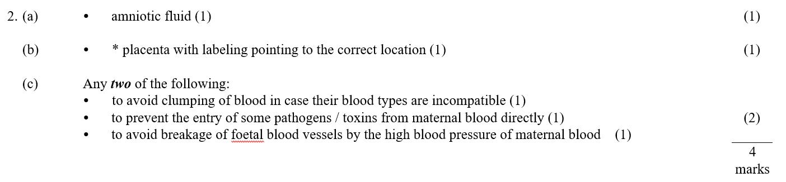

15. HKCEE Biology 2011 Paper 1 Q4

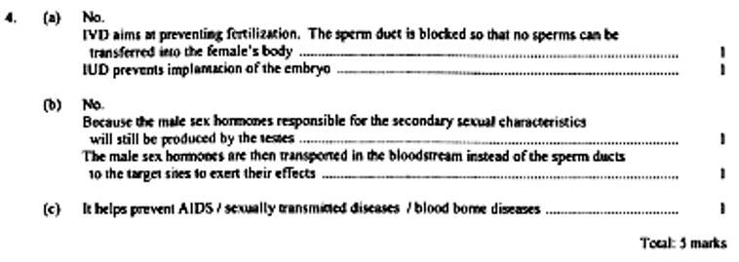

**Structured questions** (p.14*-***45**)

16 (a) (i) Organ A: oviduct (1)  
Process B: ovulation (1)  
Cell C: ovum (1)

(ii) A sperm has a long tail for swimming. (1)  
It has a large number of mitochondria for respiration to provide energy for movement. (1)  
Its acrosome contains enzymes to break down the ovum’s jelly coat in order to enter the ovum. (1)

(b) Sexual reproduction maintains or increases population of the animal species. (1)  
It increases genetic variation (1)  
through crossing over / independent assortment of homologous chromosomes / random fusion of gametes during fertilization. (1)  
Genetic variation allows the species to better adapted to environmental changes / new environments. It also allows natural selection / formation of new species to take place. (1)  
Sexual reproduction allows the expression of recessive traits. (1)

17. (a) from ovulation to start of menstruation (1)

(b) (i) 27 days (1)

(ii) 14th (1)  
to 17th (1)

(c) Loss of blood means fewer red blood cells, resulting in pale colour. (1)  
Loss of red blood cells means less haemoglobin, so less oxygen is carried by blood. (1)  
The cells cannot obtain enough oxygen for respiration, causing lack of energy and tiredness. (1)

18. (a) (i) fertilization (1)

(ii) Once a sperm has penetrated the cell membrane of an ovum, the jelly coat thickens and hardens to prevent the entry of other sperms. (1)  
This can maintain the diploid number of chromosomes in the zygote. (1)

(b) (i) Mitotic cell division (1)

(ii) • Mitotic cell division occurs in body cells, while meiotic cell division occurs in gamete-producing cells. (1)

• Mitotic cell division produces two daughter cells while meiotic cell division produces four daughter cells. (1)

• The daughter cells produced from mitotic cell division are diploid, while the daughter cells produced from meiotic cell division are haploid. (1)

• The daughter cells produced from mitotic cell division are genetically identical to each other and the parent cell, while the daughter cells produced from meiotic cell division are genetically different from each other and the parent cell. (1) (Any ***two***, 2)

(c) No. (1)  
The two embryos are formed from a fertilized ovum and are thus genetically identical. (1)

19. (a) (i) The presence of numerous villi provides a large surface area for the exchange of materials. (1)  
The embryo’s blood is close to the maternal blood. This reduces the distance for diffusion of materials. (1)  
The rich supply of blood vessels allows an efficient transport of materials away from the placenta. This maintains a steep concentration gradient of materials between the embryo’s blood and the maternal blood. (1)

(ii) glucose / amino acids / antibodies  
(or other acceptable answers) (Any ***two***, 2)

(b) Carbon monoxide combines with haemoglobin in the mother's red blood cells. As a result, less oxygen can be carried by the mother's blood. (1)  
This reduces the oxygen supply to the foetus. (1)  
The foetus cannot obtain enough oxygen for respiration. (1)  
With less energy available, its growth will be hindered.

20. (a) A: ovary (1)  
B: uterus (1)  
C: vagina (1)

(b) No ovum is present in the reproductive tract (1)  
because the ovum is released in the middle of the menstrual cycle. (1)  
The uterine lining is thinner (1)  
because it has been shedded in the previous menstruation. (1)

(c) The sperm may swim up the uterus and oviduct. (1)  
It may be stopped by a contraceptive device and die. (1)  
It may eventually fuse with ovum. (1)  
(or other acceptable answers)

(d) (i) The woman becomes infertile / sterile. (1)  
The obstruction prevents sperm and ovum from meeting. (1)

(ii) Use condoms (1)  
which prevent mixing of body fluids / prevent bacteria from entering. (1)

**Essays** (p.14*-***48**)

21. Preventing ovulation (1)

• Contraceptive pills contain synthetic female sex hormones, which prevent follicles from developing in the ovaries so that no ovulation occurs. (1)

Preventing sperms from reaching an ovum (1)

• Male condoms trap semen and prevent sperms from entering the vagina. (1)

• Vasectomy is a surgical operation in which both sperm ducts of a man is tied and cut. It ensures that sperms cannot pass through the sperm ducts. (1)

Preventing implantation of the embryo (1)

• Intrauterine device (IUD) is placed in the uterus to prevent embryos from implanting in the uterine lining. (1)

(or other acceptable answers) (Max. 7)

Communication (Max. 3)